### Experience

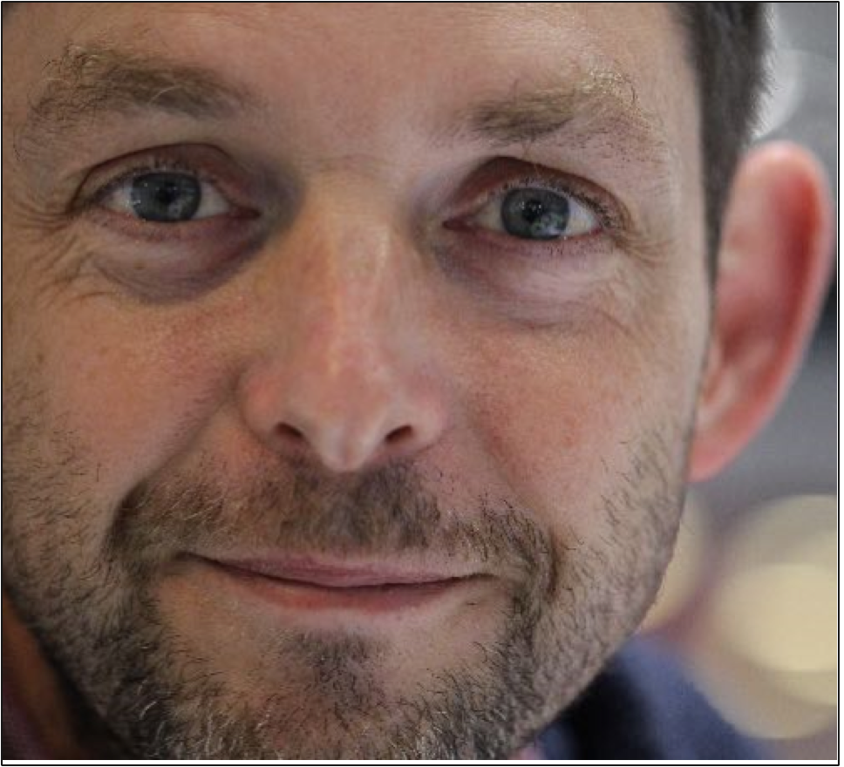

Andy Peat

Graphic designer

## Objective

Looking to develop design management opportunities.

## Proficient in

Adobe: Illustrator, InDesign, Photoshop, Quark, Affinity, WordPress, CSS, HTML, Figma, Microsoft Office, Pencil and Magic Markers.

## Visa status

British Citizen,

Permanent Hong Kong ID

## Contact

+44 (0)7928 100359

[email@andypeat.com](mailto:email@andypeat.com)

[www.andypeat.com](http://www.andypeat.com/)

Over 20 years’ experience in graphic design; developing marketing communications, packaging, print and web. I’ve worked with FMCG, Finance and Consumer electronics, in London, The Netherlands and Hong Kong. I’ve recently travelled Europe and England while also designing for various clients.

Expertise**:** Branding, Packaging, Web and digital, Retail, Creative direction, Corporate identity, Corporate literature, Concept design, Art direction, Brand guidelines, Content strategy, Copywriting Design management, Marketing.

#### AnBe creative | UK | 2018 – Present

##### Founder and Creative Director

-Created financial presentation reports for Bridgepoint.

-Developed business presentation materials and templates for Kepler Cheuvreux.

-Researched, created and published first children’s book.

-Developed online shopping assets for new innovative online retailer.

-Consulted on web design for online shopping retailer.

-Created various logos and marketing materials for local businesses.

#### Gibson Brands | Hong Kong

##### Senior Art Director | 2014 – 2017

-Overseeing design presentation to clients, leading market research, concept workshops, creating brand guidelines.

-oversaw Philips brand licensing across Asia teams.

#### Philips Design | Hong Kong

##### Senior Art Director | 2010 – 2014

-Oversaw design presentation to clients.

-Led market research and concept workshops.

-Helped develop Philips guidelines for Asia market.

-Created category specific brand guidelines that made suppliers more efficient.

-Mentored new design talent and recruited in-house and out-sourced suppliers.

##### Art Director | 2006 – 2010

-Led packaging, retail and marketing design teams.

-Oversaw local and international designers from brief to award-winning brand packaging and communications across all retail touchpoints. Working closely with category leaders as far-reaching from kitchen appliances to home cinema systems, and everywhere in-between.

**Awards:**

* iF Design Award, 2010 – Philips GoGear packaging and communication design
* iF Design Award, 2010 – Philips Activa packaging and communication design

#### Leahy Brand Design | London

##### Senior Designer | 2000 – 2006

Specialist in corporate literature, financial reports, brands and FMCG packaging.

#### Bagshawe Leahy | London

##### Freelance designer | 1995 – 2000

Liaising directly with clients, managing brands, corporate identity, and literature design projects for global clients such as Deutsche Bank, Royal Bank of Scotland and PriceWaterhouseCoopers. Packaging design for clients such as Energizer, GoldenVale, Kerry foods, Rustlers and Coleraine, from concept to print.

### Education

#### Media and Cultural Critique | Postgraduate Diploma

#### HKU Space | Hong Kong

Packaging design for clients such as Energizer, GoldenVale, Kerry foods, Rustlers and Coleraine, from concept to

#### Graphic and Media Design | BA First Class Honours

#### London College of Communication, UAL | London

Packaging design for clients such as Energizer, Goldenvale, Kerry foods, Rustlers and Coleraine, from concept to

### Volunteer roles

I was a leader with the Hong Kong Scout Association since 2009 where I helped start a new scout troop, and I have continued my involvement after moving back to the UK.

### References

#### Raymond Wong, Philips Design

##### Contact Information

#### Gregg Foster, Retired

##### Contact Information